Class 101

Discovering
Our Church Family

PARTICIPANT GUIDE

Table of Contents
WELCOME 3
SESSION ONE: OUR PURPOSE 4
The Reason for Everything 5
God’s Five Purposes for Your Life on Earth 7
Why You Need the Church 11
What Does It Mean to Be a Christian? 12
Baptism: How You Identify with God’s Family 18
The Lord’s Supper: Communion with God’s Family 23

SESSION TWO: OUR STRATEGY 25
Our Motto 26
Our Purpose Statement 27
Circles of Commitment 28
Development Diamond 29
Our Values 30
Our Constitution and By-Laws #1 Appendix 32

SESSION THREE: OUR HISTORY 33
#2 Appendix
SESSION FOUR: MOORE’S CHAPEL FAMILY 34
What Is the Church? 35
What Is our structure? 37
Why Become a Member? 38
Our Model for Membership: The First Church 40
What Are My Next Steps? 44

ANSWER KEY 46

Welcome
Class 101: Discovering Our Church Family is the first of Moore’s Chapel’s foundational classes. You were designed to be a part of a church family, and that’s exactly what Moore’s Chapel is intended to be—your family.

A healthy family has common beliefs, purposes, and commitment. That’s why we want to share with you what we believe and where we’re going.



SESSION
ONE

Our Purpose

THE REASON FOR EVERYTHING
- Everything starts with God!
The Lord has made everything for his own purpose.
PROVERBS 16:4 (GW)

Everything, absolutely everything . . . got started in him and finds its purpose in him. COLOSSIANS 1:16 (THE MESSAGE)

For everything comes from God alone. Everything lives by his power, and everything is for his glory. To him be glory evermore. ROMANS 11:36 (TLB)
- God is love.
Dear friends, let us love one another, for love comes from God . . . Whoever does not love does not know God, because God is love. 1 JOHN 4:7–8 (NIV)
- God wanted a family to demonstrate his love.
When I think of the wisdom and scope of his plan, I fall down on my knees and pray to the Father of all the great family of God—some of them already in heaven and some down here on earth. EPHESIANS 3:14–15 (TLB)
- God’s family is the church!
God’s family is the church of the living God, the pillar and foundation of the truth.
1 TIMOTHY 3:15 (GW)
- God’s family will last forever, outlasting everything else in creation.
[God] has planted eternity in the human heart, but even so, people cannot see the whole scope of God’s work from beginning to end.
ECCLESIASTES 3:11 (NLT)
[We have] the hope of life forever, which God promised to us before time began. And God cannot lie.
TITUS 1:2 (NCV)
- Although God created us last, he thought of us first. He planned the universe for his family.
I am your Creator. You were in my care even before you were born.
ISAIAH 44:2 (CEV)
He chose to give birth to us by giving us his true word. And we, out of all creation, became his prized possession.
JAMES 1:18 (NLT)
- God didn’t reveal his plan until he sent Jesus.
And God gave me the work of telling all people about the plan for his secret, which has been hidden in him since the beginning of time. He is the One who created everything. His purpose was that through the church all the rulers and powers in the heavenly world will now know God’s wisdom, which has so many forms. This agrees with the purpose God had since the beginning of time, and he carried out his plan through Christ Jesus our Lord.
EPHESIANS 3:9–11 (NCV)
- Jesus makes the whole plan possible.
It’s in Christ that we find out who we are and what we are living for . . . part of the overall purpose he is working out in everything and everyone.
Ephesians 1:11–12 (THE MESSAGE)
[Jesus] died for us so that . . . we can live with him forever.
1 Thessalonians 5:10 (NLT)
This is the plan: At the right time [God] will bring everything together under the authority of Christ—everything in heaven and on earth.
Ephesians 1:10 (NLT)
- The time is getting closer.
All creation is waiting eagerly for that future day when God will reveal who his children really are. The creation looks forward to the day when it will join God’s children in glorious freedom from death and decay.
Romans 8:19, 21 (NLT)
No mere man has ever seen, heard, or even imagined what wonderful things God has ready for those who love the Lord.
1 Corinthians 2:9 (TLB)
- In the meantime, we can practice for eternity.
We should live in this evil world with wisdom, righteousness, and devotion to God, while we look forward with hope to that wonderful day when the glory of our great God and Savior, Jesus Christ, will be revealed.
Titus 2:12–13 (NLT)

GOD’S FIVE PURPOSES
FOR YOUR LIFE ON EARTH

- God planned me for .
For you created everything, and it is for your pleasure that they exist and
were created.
Revelation 4:11 (NLT96)
The Lord takes pleasure in his people.
Psalm 149:4 (GNT)
Long before he laid down earth’s foundations, he had us in mind, had settled on us as the focus of his love.
Ephesians 1:4 (The Message)
“Love the Lord your God with all your heart and with all your soul and with all your mind. This is the first and greatest commandment.”
Matthew 22:37–38 (NIV)
“I don’t want your sacrifices—I want your love; I don’t want your offerings—I want you to know me.”
Hosea 6:6 (TLB)

The first purpose of life is .

The Bible calls this .
Some . . . people have missed the most important thing in life—they don’t know God.
1 Timothy 6:21 (TLB)
“People who don’t know God are always worrying . . .”
Matthew 6:32 (CEV)

- God formed me for .
[God’s] unchanging plan has always been to adopt us into his own family by bringing us to himself through Jesus Christ. And this gave him great pleasure.
Ephesians 1:5 (NLT96)
[God] has given us the privilege of being born again so that we are now members of God’s own family.
1 Peter 1:3 (TLB)
That family is the church of the living God, the support and foundation of the truth.
1 Timothy 3:15 (NCV)
Love your spiritual family.
1 Peter 2:17 (The Message)

The second purpose of life is .

The Bible calls this .
We belong to each other, and each needs all the others.
Romans 12:5 (TLB)

- God created me .

From the very beginning God decided that those who came to him—and all along he knew who would—should become like his Son.
ROMANS 8:29 (TLB)
We look at this Son and see . . . God’s original purpose in everything created.
COLOSSIANS 1:15 (The Message)
In your lives you must think and act like Christ Jesus.
PHILIPPIANS 2:5 (NCV)
As the Spirit of the Lord works within us, we become more and more like him.
2 CORINTHIANS 3:18 (TLB)
The third purpose of life is .
The Bible calls this .
"[Some people have] such shallow soil of character that when the emotions wear off and some difficulty arrives, there is nothing to show for it."
MARK 4:17 (The Message)
- God “shaped” me .
You shaped me first inside, then out; you formed me in my mother’s womb.
PSALM 139:13 (The Message)

S
H
A
P
E
God has made us what we are. In Christ Jesus, God made us to do good works, which God planned in advance for us to live our lives doing.
EPHESIANS 2:10 (NCV)

The fourth purpose of life is .

The Bible calls this .

- God made me .
“In the same way that you gave me a mission in the world, I give them a mission in the world.”
JOHN 17:18 (The Message)
Through Christ, God made peace between us and himself, and God gave us the work of telling everyone about the peace we can have with him . . . So we have been sent to speak for Christ.
2 CORINTHIANS 5:18, 20 (NCV)
The most important thing is that I complete my mission, the work that the Lord Jesus gave me—to tell people the Good News about God’s grace.
ACTS 20:24 (NCV)
Make the most of your chances to tell others the Good News.
COLOSSIANS 4:5 (TLB)

The fifth purpose of life is .

The Bible calls this .

The Big Key
I can’t fulfill God’s purposes .

The big takeaway here is you can’t fulfill God’s purposes by yourself. You need to be part of God’s family.

WHY YOU
NEED THE CHURCH

The Purpose of the Church Is to Help People Fulfill
God’s Purposes for Their Lives

Since we are all one body in Christ, we belong to each other, and each of us needs all the others.
ROMANS 12:5 (NLT96)
Having a church family will help you:
• Center your life around God (worship)
• Connect with other believers (fellowship)
• Cultivate spiritual maturity (discipleship)
• Contribute something back (ministry)
• Communicate God’s message (mission)
What’s Driving Your Life?

This world is fading away, along with everything it craves. But if you do the will of God, you will live forever.
1 JOHN 2:17 (NLT96)
[God’s] plans endure forever; his purposes last eternally.
PSALM 33:11 (GNT)
“Are you tired? Worn out? Burned out on religion? Come to me . . . and you’ll recover your life . . . and you’ll learn to live freely and lightly.”
MATTHEW 11:28, 30 (The Message)
It makes no difference who you are or where you’re from—if you want God and are ready to do as he says, the door is open.
ACTS 10:35 (The Message)

What does it mean
to be A Christian?

Most people live their entire lives without ever knowing “WHY?” They exist year after year with no idea of why they live or God’s purpose for their lives. The most basic question a person asks is, “What is the meaning of life?”

Everyone wants to be happy. People try many ways.

• Some look for happiness by acquiring possessions.
• Some look for happiness by experiencing pleasure.
• Some look for happiness by gaining prestige and power.

But real happiness comes from understanding my purpose in life.

Why Am I Here?
- God created me to me.
The LORD appeared to us in the past saying: “I have loved you with an
everlasting love.”
Jeremiah 31:3 (NIV)
Even before the world was made, God had already chosen us to be his through our union with Christ. . . Because of his love God had already decided that through Jesus Christ he would make us his children—this was God’s pleasure and purpose.
Ephesians 1:4–5 (GNT)

- We were created to a personal relationship with God and to
all of the rest of God’s creation. This makes us special.
So God created human beings, making them to be like himself. He created them male and female, blessed them, and said, “Have many children, so that your descendants will live all over the earth and bring it under their control. I am putting you in charge of the fish, the birds, and all the wild animals.”
Genesis 1:27–28 (GNT)
[God] richly provides us with everything for our enjoyment.
1 Timothy 6:17 (NIV)
[Jesus said,] “I have come in order that you might have life­—life in all its fullness!”
John 10:10 (GNT)
- When we know and love God and live in harmony with his purpose for our lives, it produces tremendous benefits in our lives.
CLEAR CONSCIENCE  Romans 8:1 | Life and Peace  Romans 8:6 | Help with Weakness  Romans 8:26
Purpose  Romans 8:28 | Confidence  Romans 8:31 | Security  Romans 8:39
Power and Strength  Philippians 4:13 | Fulfillment  Philippians 4:19 | Freedom  John 8:32, 36

What’s the Problem?

- People have a natural desire to and to ignore God’s principles
for living.
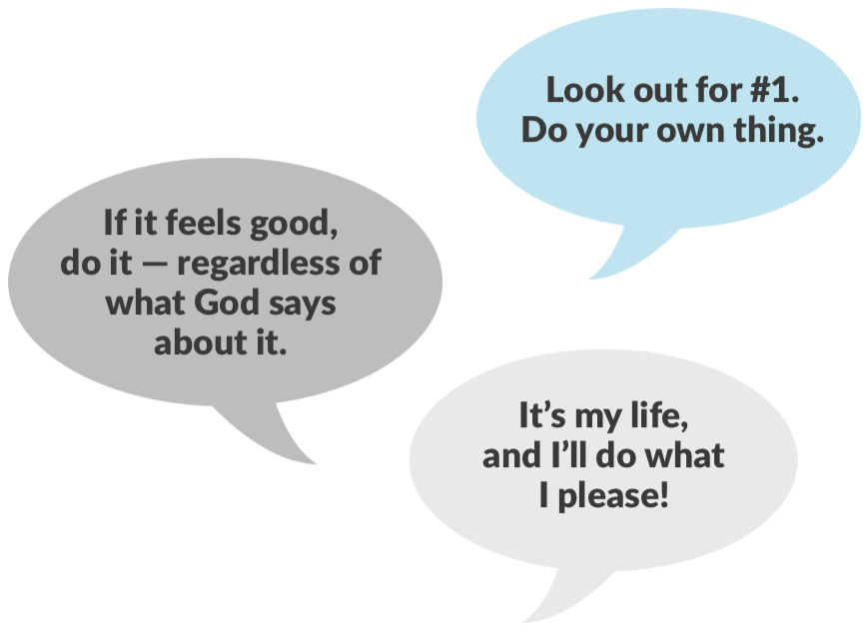
- The Bible calls this attitude .
All of us like sheep have gone astray; each of us has turned to his own way.
Isaiah 53:6 (MEV)
If we say that we have no sin, we are only fooling ourselves and refusing to accept the truth.
1 John 1:8 (TLB)
Sin breaks our close relationship with God. It causes us to fear God and try to live our lives outside of his will.

The trouble is that your sins have cut you off from God.
Isaiah 59:2 (TLB)
Yes, all have sinned; all fall short of God’s glorious ideal.
Romans 3:23 (TLB)
When our relationship with God is not right, it causes problems in every area of our lives—marriage, career, relationships, finances, etc.

“WHEN PEOPLE HAVE PROBLEMS, THEY
OFTEN TRY MANY DIFFERENT WAYS OF
COPING BEFORE TURNING TO GOD.”

There is a way that seems right to a man, but in the end it leads to death.
Proverbs 16:25 (NIV84)
Even when we know that our deepest need is God, we often try wrong ways of getting to know him.

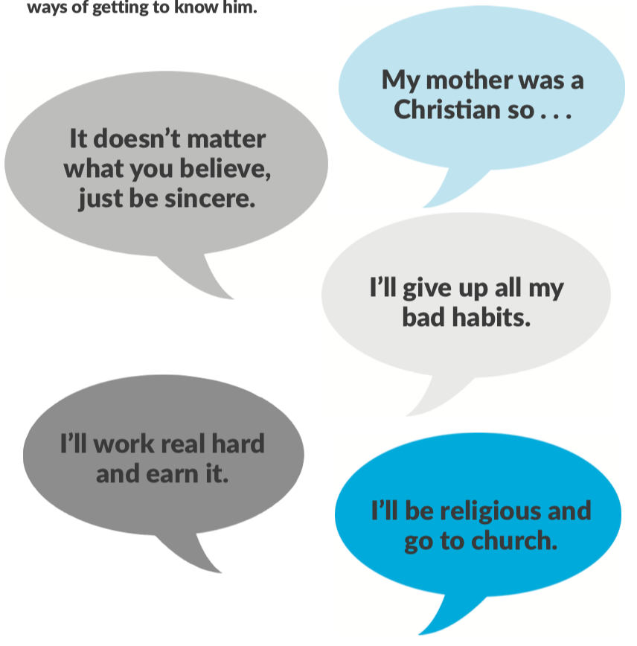

What’s the Solution?

Jesus answered, “I am the way and the truth and the life. No one comes to the Father except through me.”
John 14:6 (NIV)
God himself came to earth as a human being to bring us back to himself. If any other way would have worked, Jesus Christ would not have had to come. The way is in the person of Jesus Christ.

“JESUS HAS ALREADY TAKEN CARE OF YOUR SIN PROBLEM.”

The wages of sin is death, but the gift of God is eternal life through Jesus Christ
our Lord.
Romans 6:23 (NIV84)
God did this for us because he loves us and wants us to know him.
God demonstrated his love for us in that while we were still separated from God by sin, Christ died for us.
Romans 5:8 (AP)
God is on one side and all the people on the other side, and Christ Jesus, himself man, is between them to bring them together, by giving his life for all mankind.
1 Timothy 2:5 (TLB)
God has already done his part to restore our relationship to him. He took the initiative. Now he waits for each of us to individually accept what he has done for us.

What Does God Want Me to Do?

- that God has not been first place in your life and ask him to forgive your sins.
If we confess our sins, he is faithful and just and will forgive us our sins and cleanse us from every wrong.
1 John 1:9 (AP)
- that Jesus died to pay for your sins and that he rose again on Easter and is alive today.
If you confess with your mouth, “Jesus is your Lord,” and believe in your heart that God raised him from the dead, you will be saved.
Romans 10:9 (NIV84)
Salvation is found in no one else, for there is no other name [Jesus] . . . by which we must be saved.
Acts 4:12 (NIV)
- God’s free gift of salvation. Don’t try to earn it.
For it is by grace you are saved, through faith—and this not from yourselves, it is the gift of God—not by works, so that no one can boast.
Ephesians 2:8–9 (NIV84)
- Jesus Christ to come into your life and be the director (Lord) of your life.
"To all who received him, he gave the right to become children of God. All they needed to do was to trust him to save them. All those who believe this are reborn!—not a physical rebirth resulting from human passion or plan—but from the will of God."
John 1:12–13 (TLB)
[Jesus says,] “Listen! I stand at the door and knock. If anyone hears My voice and opens the door, I will come in.”
Revelation 3:20 (HCSB)
PRAYER OF
COMMITMENT

Dear Jesus,
Thank you for making me and loving me, even when I’ve ignored you and gone my own way. I realize I need you in my life, and I’m sorry for my sins. I ask you to forgive me. Thank you for dying on the cross for me. Please help me to understand it more. As much as I know how, I want to follow you from now on. Please come into my life and make me a new person inside. I accept your gift of salvation. Please help me grow now as a Christian.
In Jesus’ name,
Amen.

Whoever calls upon the name of the Lord will be saved.
Romans 10:13 (GW)

BAPTISM: HOW YOU
IDENTIFY WITH GOD’S FAMILY

What is the Meaning of Baptism?

- It illustrates Christ’s , , and resurrection.
Christ died for our sins . . . he was buried . . . and . . . he rose again.
1 CORINTHIANS 15:3–4 (KJV)
When we are lowered into the water, it is like the burial of Jesus; when we are raised up out of the water, it is like the resurrection of Jesus.
ROMANS 6:4 (The Message)
For when you were baptized, you were buried with Christ, and in baptism you were also raised with Christ.
COLOSSIANS 2:12 (GNT)
- It illustrates my as a Christian.
When someone becomes a Christian, he becomes a brand new person inside. The old life is gone; a new life has begun!
2 CORINTHIANS 5:17 (TLB/NLT)
Your baptism in Christ was not just washing you up for a fresh start. It also involved dressing you in an adult faith wardrobe—Christ’s life, the fulfillment of God’s original promise.
GALATIANS 3:27 (The Message)
Baptism doesn’t make you a believer—it shows that you already believe. Baptism does not “save” you, only your faith in Christ does that. Baptism is like a wedding ring—it’s the outward symbol of the commitment you made in your heart.

- It demonstrates my into Christ’s body, the church.
We each used to independently call our own shots, but then we entered into a large and integrated life in which [Christ] has the final say in everything. (This is what we proclaimed in word and action when we were baptized.) Each of us is now a part of his resurrection body.
1 CORINTHIANS 12:13 (The Message)

Why Should I Be Baptized?

- To follow the example set by .
At that time Jesus came from Nazareth . . . and was baptized by John in the Jordan.
MARK 1:9 (NIV)
- Because Christ it.
“Go, then, to all peoples everywhere and make them my disciples: baptize them in the name of the Father, the Son, and the Holy Spirit, and teach them to obey everything I have commanded you.”
MATTHEW 28:19–20 (GNT)

- It shows that I really am a .
Many of the [people] who heard Paul believed and were baptized.
ACTS 18:8 (NIV)
We know that we have come to know him if we obey his commands.
1 JOHN 2:3 (NIV84)
Why Be Baptized By Immersion?

- Because was baptized that way.
As soon as Jesus was baptized, he went up out of the water.
MATTHEW 3:16 (NIV)

- Every baptism in the was by immersion.
Two examples:

Then both Philip and the [man] went down into the water and Philip baptized him. When they came up out of the water . . .
ACTS 8:38–39 (NIV)
Now John also was baptizing at Aenon near Salim, because there was plenty
of water.
JOHN 3:23 (NIV)

- The word “baptize” means to water.
The Greek word baptizo means “to immerse and dip under water.”
- Baptism is the best symbol of a burial and resurrection!
The founders from different denominations agree with the statement above.

MARTIN LUTHER: “I would have those who are to be baptized to be entirely immersed, as the word imports and the mystery signifies.”

JOHN CALVIN: “The word ‘baptize’ signifies to immerse. It is certain that immersion was the practice of the ancient church.”

JOHN WESLEY: “We are buried with him, alluding to the ancient manner of baptizing by immersion.”

THE NEW CATHOLIC ENCYCLOPEDIA: “The biblical form of baptism was unquestionably immersion. In the Catholic church, immersion seems to have prevailed until the twelfth century.”

Who Should Be Baptized?

Every person who has in Christ.

Many of them believed his message and were baptized.
Acts 2:41 (GNT)
Simon believed in Christ and was baptized.
Acts 8:13 (NLV)
But when they believed Philip as he preached the good news . . . and the name of Jesus Christ, they were baptized, both men and women.
Acts 8:12 (NIV)

At , Moore’s Chapel we wait until our children are old enough to believe and understand the true meaning of baptism before we baptize them.

Some churches practice a “baptism of confirmation” for children. This ceremony is intended to be a covenant between the parents and God on the behalf of the child. The parents promise to raise their child in the faith until the child is old enough to make his own personal confession of Christ. This custom began about 300 years after the Bible was completed. This is different from the baptism talked about in the Bible, which was only for those old enough to believe. The purpose is to publicly confess your personal commitment to Christ.
At Moore’s Chapel, it is a membership requirement that every member must have been baptized the way Jesus demonstrated, even though many of us were “confirmed” as children.

When Should I Be Baptized?

“AS SOON AS YOU HAVE BELIEVED!”

Those who believed . . . were baptized . . . that day!”
ACTS 2:41 (NLV)
Then Philip spoke. Starting with that passage, Philip told the official the Good News about Jesus. As they were going along the road, they came to some water. The official said to Philip, “Look, there’s some water. What can keep me from being baptized?” The official ordered the carriage to stop. He and Philip stepped into the water, and Philip baptized him.
ACTS 8:35–38 (GW)
There is no reason to delay. As soon as you have decided to receive Christ into your life, you can and should be baptized. If you wait until you are “perfect,” you’ll never feel “good enough!”

Practical Questions

- Can my family be baptized together?

Yes! If each family member fully understands the meaning of baptism, and each one has personally placed his/her trust in Christ for salvation, we encourage families to be baptized at the same time. It is a wonderful expression of commitment.

Young children who wish to be baptized can attend a baptism class held regularly throughout the year through Saddleback Kids.

However, it is important to remember that baptism is a personal statement of faith, not a family tradition. It is usually not wise to delay your baptism while waiting on other family members to accept Christ, particularly children. This puts an undue pressure on them and delays your obedience.

- What should I wear when I am baptized?

We have baptism T-shirts you can wear over your swimsuit or any clothes you feel comfortable in. We also provide changing rooms, towels, and shorts you can use. Also, modesty is key.

- Will I have to say anything?

No. At the beginning of the service, one of our pastors will briefly explain the meaning of baptism. You will wait at the edge of the pool for your turn to be baptized. A pastor will introduce you, briefly lower you just under the water, and then you can leave the pool, dry off, and watch the others. We encourage you to invite all your relatives and friends to attend your baptism! You will be given a photo and certificate of your baptism.

- Special needs?

All of our pastors can perform a private baptism in special circumstances.

THE LORD’S SUPPER:
COMMUNION WITH GOD’S FAMILY

Jesus never asked his disciples to remember his birth. But he did instruct them to remember his death and resurrection. He gave the church two visible symbols (called ordinances) as reminders of his death. These two ordinances are baptism and the
Lord’s Supper.

The Lord’s Supper is an object lesson that represents a great spiritual truth for believers.

What Is the Lord’s Supper?

To find the answer to what is the Lord’s Supper, let’s read, one verse at a time,
1 Corinthians 11:23–26 (NIV).

- It is a .
The Lord Jesus, on the night he was betrayed, took bread.
VERSE 23
- It is a .
And when he had given thanks, he broke it and said, “This is my body, which is for you; do this in remembrance of me.”
VERSE 24
- It is a .
In the same way . . . he took the cup, saying, “This cup is the new covenant in my blood . . . drink it, in remembrance of me.”
VERSE 25
- It is a .
For whenever you eat this bread and drink this cup, you proclaim the Lord’s death until he comes.
VERSE 26
Who Should Take the Lord’s Supper?

Only those who are already (Mark 14:22–26).

For anyone who eats and drinks without recognizing the body [of the Lord] eats and drinks judgment on himself.
1 CORINTHIANS 11:29 (BSB)
How Do I Prepare Myself for
the Lord’s Supper?

So then, whoever eats the bread or drinks the cup of the Lord in an unworthy manner will be guilty of sinning against the body and blood of the Lord. Everyone ought to examine themselves before they eat of the bread and drink from the cup.
1 CORINTHIANS 11:27–28 (NIV)
You prepare yourself through:

- Self-Examination (1 Corinthians 11:27)
- Confessing My Sins (1 John 1:9)
- Recommitment (Romans 12:1)
- Restoring Relationships (Matthew 5:23–24)

When and How Often Should We Observe
the Lord’s Supper?

Jesus never said when or how often believers should observe the Lord’s Supper. He instituted it on a Thursday night. In the Bible, Christians observed the communion in small groups in homes.

SESSION
TWO

Our Strategy

The Great Commandment

“‘Love the Lord your God with all your heart . . . soul and . . . mind.’ This is the first and greatest commandment. And the second is like it: ‘Love your neighbor as yourself.’ All the Law and the Prophets hang on these two commandments.”
MATTHEW 22:37–40 (NIV)
The Great Commission

“Go and make disciples of all nations, baptizing them in the name of the Father and of the Son and of the Holy Spirit, and teaching them to obey everything I have commanded you.”
MATTHEW 28:19–20 (NIV)

OUR MOTTO

A Great Commitment . . .
. . . to the Great
and the Great
. . . will grow a Great Church!

OUR PURPOSE STATEMENT

“TO BRING PEOPLE TO JESUS AND MEMBERSHIP IN HIS FAMILY,

DEVELOP THEM TO CHRIST-LIKE MATURITY,

AND EQUIP THEM FOR THEIR MINISTRY IN THE CHURCH

AND THEIR LIFE MISSION IN THE WORLD,

IN ORDER TO MAGNIFY GOD’S NAME.”

CIRCLES OF
COMMITMENT

Stages of Spiritual Growth

The Bible explains that spiritual growth is a journey:

- People live at different stages of commitment and spiritual maturity.

- We only grow by making commitments.

The Purpose Driven strategy moves people from the outer fringe of our church to the center by encouraging personal spiritual growth through a series of classes and covenants.

Let’s examine the numbers in each of the stages represented in the chart below.

Fill in the name of this campus here:

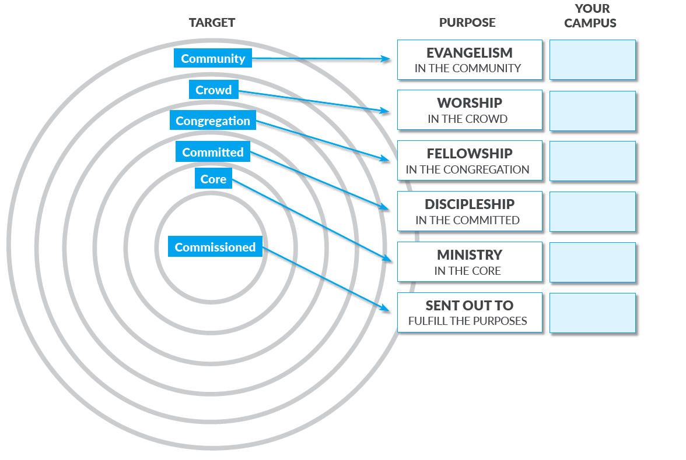

Development
Diamond

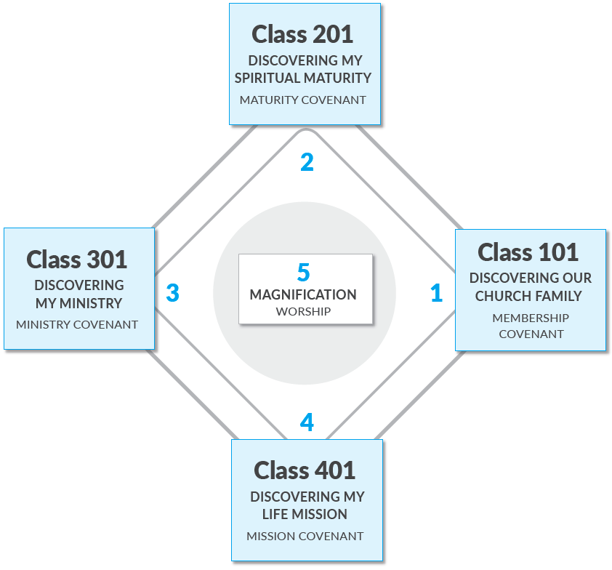

OUR
VALUES
STATEMENTS

Our Value Statements

________________________________________________________

Be kind and compassionate to one another, forgiving each other, just as God through Christ has forgiven you.
EPHESIANS 4:32 (NIV/NLT)
As God’s chosen people, holy and dearly loved, clothe yourselves with compassion, kindness, humility, gentleness and patience.
COLOSSIANS 3:12

________________________________________________________

Show respect for all people. Love your brothers and sisters in God’s family.
1 PETER 2:17 (ERV)

________________________________________________________

But be doers of the word, and not hearers only, deceiving yourselves.
JAMES 1:22 (ESV)

If anyone, then, knows the good they ought to do and doesn’t do it, it is sin for them.
JAMES 4:17 (NIV)

________________________________________________________

Let us consider how to spur one another on to love and good deeds. Let us not neglect meeting together . . . but let us encourage one another, and all the more.
HEBREWS 10:24–25 (BSB)

OUR FAITH
STATEMENT

Our Beliefs
In essential beliefs—we have .
There is one body and one Spirit . . . one Lord, one faith, one baptism; one God and Father of all.
EPHESIANS 4:4–6 (NIV)
In nonessential beliefs—we allow .
Accept him whose faith is weak, without passing judgment on disputable matters . . . Who are you to judge someone else’s servant? To his own master he stands or falls . . . So then, each of us will give an account of himself to God . . . So whatever you believe about these things keep between yourself and God.
ROMANS 14:1, 4, 12, 22 (NIV84)
In all our beliefs—we show .
If I . . . hold in my mind not only all human knowledge but the very secrets of God, and if I also have that absolute faith which can move mountains, but have no love, I amount to nothing at all.
1 CORINTHIANS 13:2–3 (PHILLIPS)

Our Consistitution
and By-Laws -see

#1 appendix

SESSION
THREE

Our History

Appendix #2

SESSION
FOUR

Our Moore’s Chapel
Family

BENEFITS OF MEMBERSHIP
“THE DIFFERENCE BETWEEN BEING A MEMBER AND AN ATTENDER MEANS BEING A PARTICIPATOR, NOT JUST A SPECTATOR, A BELONGER, NOT JUST A BYSTANDER, A CONTRIBUTOR, NOT JUST A CONSUMER.”

Let the peace of heart that comes from Christ be always present in your hearts and lives, for this is your responsibility and privilege as members of his body. And always be thankful.
COLOSSIANS 3:15 (TLB)

WHAT IS
THE CHURCH?

- The church is a _________________________________________________.
You should be like one big happy family, full of sympathy toward each other, loving one another with tender hearts and humble minds.
1 PETER 3:8 (TLB)
Galatians 6:10, Hebrews 2:10–12, 1 Peter 4:17

So we operate on the basis of not .
Don’t reprimand a senior member of your church, appeal to him as a father. Treat the young men as brothers, and the older women as mothers. Treat the younger women as sisters, and no more.
1 TIMOTHY 5:1–2 (PHILLIPS)
[A pastor] must manage his own family well and see that his children obey him, and he must do so in a manner worthy of full respect. (If anyone does not know how to manage his own family, how can he take care of God’s church?)
1 TIMOTHY 3:4–5 (NIV)
- The church is a .
1 Corinthians 12:27, Ephesians 5:23, Ephesians 1:22–23, Colossians 1:18, 2:19

We are a body, not a business! We are an organism, not an organization!

Therefore, we function on the basis of , not
.
For just as each of us has one body with many members, and these members do not all have the same function, so in Christ we, though many, form one body, and each member belongs to all the others. We have different gifts, according to the grace given to each of us.
ROMANS 12:4–6 (NIV)

In an organization, “maintenance” becomes the focus. But in an organism, “ministry” is the focus.
At Moore’s Chapel we have a simple structure so we can maximize
and minimize .
[God] gave . . . some to be pastors and teachers, to prepare God’s people for works of service, so that the body of Christ may be built up.
EPHESIANS 4:11–12 (NIV84)

What is our
structure?

- The people are the .
- The pastors are the .
Currently there are over different ministries in our church founded and operated by members.
- The church is a .
This is Jesus’ favorite description of the church.
John 10:1–30, Matthew 26:31, Matthew 25:33
Therefore, it is cared for and led by .
Again Jesus said, “Simon son of John, do you love me?” He answered, “Yes, Lord, you know that I love you.” Jesus said, “Take care of my sheep.”
JOHN 21:16 (NIV)
Three different terms are used in the New Testament to refer to the same church leaders:
“POIMEN” =
“PRESBUTEROS” =
“EPISCOPOS” =
To the elders among you . . . Be shepherds of God’s flock that is under your care, watching over them.
1 PETER 5:1–2 (NIV)
Paul sent to Ephesus for the elders of the church. When they arrived, he said to them . . . “Keep watch over yourselves and all the flock of which the Holy Spirit has made you overseers. Be shepherds of the church of God.”
ACTS 20:17–18, 28 (NIV)
See also Titus 1:5–7, 1 Timothy 5:17.

WHY BECOME
A MEMBER?
- It’s an act of obedience to Christ’s commands.
God expects every believer to join a local church. In fact, there are over 50 commands in the New Testament you cannot follow unless you commit to joining a local body of believers. Without a church family, you’re a spiritual orphan.

Be devoted to each other like a loving family.
ROMANS 12:10 (GW)
You are members of God’s very own family, citizens of God’s country, and you belong in God’s household with every other Christian.
EPHESIANS 2:19 (TLB)
- It’s a counter-cultural choice that shows maturity.
Immaturity is the inability to make and keep commitments. Today’s culture promotes immaturity everywhere: “Keep your options open. . . don’t commit to a job, a marriage,
a church. . . anything.” Even many believers have a superficial consumer’s attitude of “shopping and hopping”—attending different churches each week without being
dedicated or loyal to any specific church family. You cannot build character without making commitments.

My friends, stop thinking like children. Think like mature people and be as innocent as tiny babies.
1 CORINTHIANS 14:20 (CEV)
Christ loved the church, and he gave his life for her.
EPHESIANS 5:25
- It’s a necessary step in your spiritual development.
First they gave themselves to the Lord; and then, by God’s will they gave themselves to us as well.
2 CORINTHIANS 8:5 (GNT)
They helped the believers grow in love for God and each other.
ACTS 14:22 (TLB)

- It provides spiritual protection.

TO PASTORS:
Guard and [protect] the whole flock of God over which the Holy Spirit has appointed you overseers [and guardians]. [Care for and] shepherd the Church of God which He bought with His own blood.
ACTS 20:28 (AMP)
TO MEMBERS:
Obey your spiritual leaders, and do what they say. Their work is to watch over your souls, and they are accountable to God. Give them reason to do this with joy and not with sorrow. That would certainly not be for your benefit.
HEBREWS 13:17 (NLT)

OUR MODEL FOR
MEMBERSHIP:
THE FIRST CHURCH

What the First Christians Did in the Jerusalem Church

And every day, in the Temple and from house to house, they continued to teach and preach this message: “Jesus is the Messiah.”
ACTS 5:42 (NLT)
All the believers met together . . . and shared everything they had . . . They worshiped together regularly in the temple courts. They also met together in small groups in homes and fellowshipped with communion and eating together. They also shared whatever they had with joy and generosity. They praised God together and the whole city liked them so every day more people were saved, and the Lord added to the number of believers in the church.
ACTS 2:44, 46–47 (NLT)
1. They united into a congregation.
2. They shared to meet each other’s needs.
3. They worshiped in the Temple courts (multiple venues/campuses).
4. They met in small groups in homes for fellowship.
5. They celebrated communion.
6. They ate together.
7. They gave generously and joyfully.
8. They built a reputation for love.
9. They brought people to Christ every day.
10. Never stopped growing!

What Does It Mean to Be a Member of Moore’s Chapel?

The Bible is very clear about the privileges and responsibilities of belonging to a church family. These are spelled out in our Membership Covenant.

Having received Jesus Christ as my Lord and Savior and been baptized by full immersion, and being in agreement with Moore’s Chapel’s statements, strategy, and structure, I now feel led by the Holy Spirit to unite with the Saddleback Church family. In doing so, I commit myself to God and to the other members to do the following:

- I will protect the unity of my church.
- By acting in love towards other members
- By refusing to gossip and by resolving conflicts using Matthew 18:15–17
- By following the leaders
“If another believer sins against you, go privately and point out the offense. If the other person listens and confesses it, you have won that person back. But if you are unsuccessful, take one or two others with you and go back again, so that everything you say may be confirmed by two or three witnesses. If the person still refuses to listen, take your case to the church. Then if he or she won’t accept the church’s decision, treat that person as a pagan or a corrupt tax collector.”
MATTHEW 18:15–17 (NLT)
So let us concentrate on the things which make for harmony, and on the growth of one another’s character.
ROMANS 14:19 (PHILLIPS)
Live in complete harmony with each other—each with the attitude of Christ toward the other.
ROMANS 15:5 (TLB)
Now that by your obedience to the truth you have purified yourselves and have come to have a sincere love for other believers, love one another earnestly with all your heart.
1 PETER 1:22 (GNT)
Do not let any unwholesome talk come out of your mouths, but only what is helpful for building others up according to their needs, that it may benefit those who listen.
EPHESIANS 4:29 (NIV)
Obey your leaders and submit to them, for they keep watch over your souls and will give an account for their work. Let them do this with joy and not with complaints, for this would be no advantage for you.
HEBREWS 13:17 (NET)

- I will share the responsibility of my church.
- By praying for its growth
- By inviting the unchurched to attend
- By warmly welcoming those who visit
We always thank God for all of you and pray for you constantly.
1 THESSALONIANS 1:2 (NLT)

“ ‘Go out into the country lanes . . . and urge anyone you find to come, so that the house will be full.’ ”
LUKE 14:23 (TLB)
So warmly welcome each other into the church, just as Christ has warmly welcomed you; then God will be glorified.
ROMANS 15:7 (TLB)

- I will serve the ministry of my church.
- By discovering my gifts and talents
- By being equipped by my pastors to serve
- By developing a servant’s heart
Serve one another with the particular gifts God has given each of you.
1 PETER 4:10 (PHILLIPS)
It was [God] who “gave gifts to people”; he appointed . . . others to be pastors and teachers. He did this to prepare all God’s people for the work of Christian service, in order to build up the body of Christ.
EPHESIANS 4:11–12 (GNT)
When you do things, do not let selfishness or pride be your guide. Instead, be humble and give more honor to others than to yourselves. Do not be interested only in your own life, but be interested in the lives of others. But [Christ] gave up his place with God and made himself nothing. He was born as a man and became like a servant.
PHILIPPIANS 2:3–4, 7 (NCV)

- I will support the testimony of my church.
- By attending faithfully
- By living a growing and godly life
- By giving regularly
Let us not give up the habit of meeting together . . . let us encourage one another.
HEBREWS 10:25 (GNT)
But whatever happens, make sure that your everyday life is worthy of the Gospel
of Christ.
PHILIPPIANS 1:27 (PHILLIPS)
On every Lord’s Day each of you should put aside something from what you have earned during the week.
1 CORINTHIANS 16:2 (TLB)
One-tenth of all crops belongs to the Lord, including the crops from fields and the fruit from trees. That one-tenth is holy to the Lord.
LEVITICUS 27:30 (NCV)

WHAT ARE MY
NEXT STEPS?

The Purpose Driven Life Discovery Process

Congratulations! You have successfully completed the membership class. There are four questions you need to ask yourself to continue your journey on the purpose driven life development process.

- Have you committed your life to Jesus Christ and trusted him for salvation?

- Have you been baptized by immersion (under water) after you committed your life
to Christ?

- Have you completed Class 101: Discovering Our Church Family? You’ve just done that!

- Do you desire to become a member of Moore’s Chapel Baptist Church and to abide by the Moore’s Chapel Membership Covenant?

We are praying the answer is yes to all four.

In this class, we’ve just barely scratched the surface of all that goes on at Moore’s Chapel Baptist Church.

Your next step is to take
Class 201: Discovering My Spiritual Maturity.

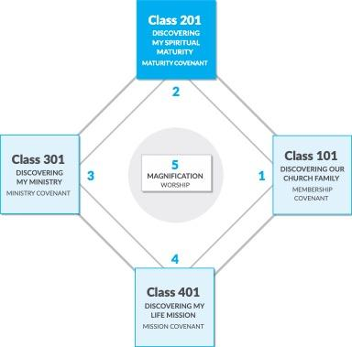

Answer Key

ANSWER KEY
SESSION ONE: OUR PURPOSE
God’s Five Purposes
for Your Life On Earth
- God planned me for HIS PLEASURE.
The first purpose of life is KNOWING AND LOVING GOD.
The Bible calls this WORSHIP.
- God formed me for HIS FAMILY.
The second purpose of life is TO LOVE OTHERS.
The Bible calls this FELLOWSHIP.
- God created me TO BECOME LIKE CHRIST.
The third purpose of life is GROWING TO MATURITY.
The Bible calls this DISCIPLESHIP.
- God “shaped” me TO SERVE HIM.
SPIRITUAL GIFTS
HEART
ABILITIES
PERSONALITY
EXPERIENCES
The fourth purpose of life is TO SERVE GOD BY SERVING OTHERS.
The Bible calls this MINISTRY.
- God made me FOR A MISSION.
The fifth purpose of life is TO TELL OTHERS ABOUT HIM.
The Bible calls this EVANGELISM.

The Big Key
I can’t fulfill God’s purposes BY MYSELF.

What Does It Mean to Be
a Christian?
Why Am I Here?
- God created me to LOVE me.
- We were created to ENJOY a personal relationship with God and to MANAGE all of the rest of God’s creation. This makes us special.
What’s the Problem?
- People have a natural desire to BE THE BOSS and to ignore God’s principles for living.
- The Bible calls this attitude SIN.
What Does God Want Me to Do?
- ADMIT that God has not been first place in your life and ask him to forgive your sins.
- BELIEVE that Jesus died to pay for your sins and that he rose again on Easter and is alive today.
- ACCEPT God’s free gift of salvation. Don’t try to earn it.
- INVITE Jesus Christ to come into your life and be the director (Lord) of your life.

Baptism: How You Identify
with God’s Family
What is the Meaning of Baptism?
- It illustrates Christ’s DEATH, BURIAL, and resurrection.
- It illustrates my NEW LIFE as a Christian.
- It demonstrates my INCORPORATION into Christ’s Body, the church.
Why Should I Be Baptized?
- To follow the example set by JESUS CHRIST.
- Because Christ COMMANDED it.
- It shows that I really am a BELIEVER.
Why Be Baptized by Immersion?
- Because JESUS was baptized that way.
- Every baptism in the BIBLE was by immersion.
- The word “baptize” means to SUBMERSE INTO water.
Who Should Be Baptized?
Every person who has BELIEVED in Christ.

The Lord’s Supper: Communion with
God’s Family
What is the Lord’s Supper?
- It is a SIMPLE ACT.
- It is a REMINDER.
- It is a SYMBOL.
- It is a STATEMENT OF FAITH.
Who Should Take the Lord’s Supper?
Only those who are already BELIEVERS (Mark 14:22–26).

SESSION TWO: OUR STRATEGY
Our Motto
A Great Commitment . . . to the Great COMMANDMENT and the Great COMMISSION will grow a Great Church!

Our Value Statements

Our Faith Statement

Our Constitution
Appendix

Our Beliefs
In essential beliefs—we have UNITY.
In nonessential beliefs­—we allow LIBERTY.
In all our beliefs—we show CHARITY.

SESSION FOUR: OUR SADDLEBACK FAMILY
What is the Church?
- The church is a FAMILY.
So we operate on the basis of RELATIONSHIPS not RULES.
- The church is a BODY.
Therefore, we function on the basis of SPIRITUAL GIFTS, not ELECTED OFFICES.
At Saddleback we have a simple structure so we can maximize MINISTRY and minimize MAINTENANCE.
What Is Our Structure?
- The people are the MINISTERS.
- The pastors are the ADMINISTERS.
Currently there are over 500 different ministries founded and operated by our members.
- The church is a FLOCK.
Therefore, it is cared for and led by SHEPHERDS.
“POIMEN” = PASTOR
“PRESBUTEROS” = ELDER
“EPISCOPOS” = OVERSEER / BISHOP

